The ratio of the ____________________ is equivalent to the ________________.

The ratio of the ____________________ is equal to the ____________________ of the __________________.

Examples:

1. The scale drawing below shows an enlarged computer chip. When measured, each side of the scale drawing of the square chip is 4 cm.

a. What is the perimeter of the drawing?

b. What is the perimeter of the actual chip?

c. What is the area of the drawing?

d. What is the area of the actual chip?

2. The scale drawing of a miniature glass mosaic tile helps you to see the detailing on the tile.

a. What are the perimeter and area of the scale drawing?

b. What is the perimeter and area of the actual tile?

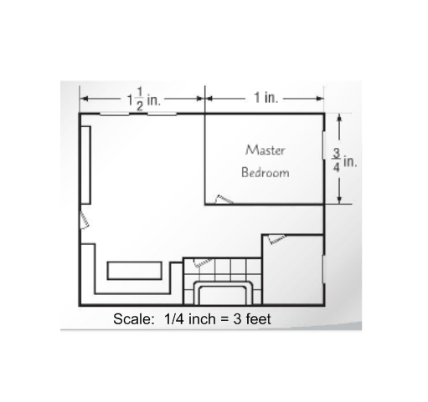

3. What are the actual perimeter and area of the master bedroom in the blueprint shown below?

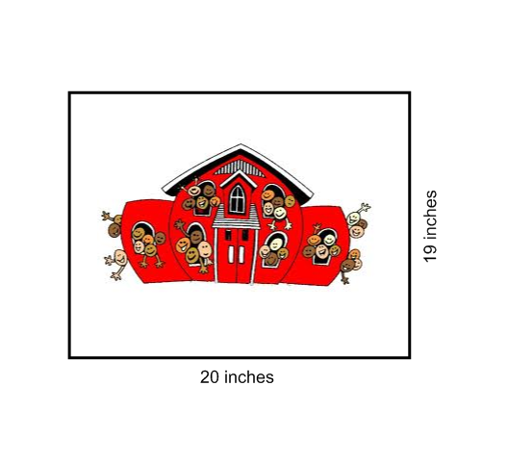

4. Tyson created a scale drawing of his school using the scale 1 in = 3 ft. What is the actual area of his school in square feet?

5. Central Park is a rectangular park in New York City, NY. A scale drawing of the park is shown below. What are the actual area and perimeter of the park?

 12 cm

2 ½ cm