Scale Drawings – RECAP
When working with scale drawings, use the ____________________ to set up a ________________, making sure to put the part (model or actual) you are solving for in the _________________.

Why do we put the other units on a diagonal?_________________________________________

Example Problems:
1. The scale of a town map is ¼ in = 2 miles. If the fire station and town hall appear 3$\frac{1}{8}$ inches apart on the map, how far apart are they really?
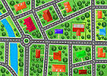
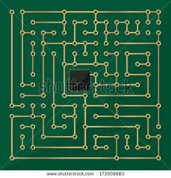
2. To investigate the parts of a microchip, a scientist drew a diagram using the scale ½ mm = 5 cm. If the length of the microchip is really 3 ¼ mm, how long does it appear on the diagram?

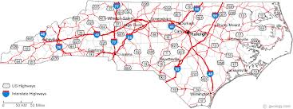
3. A map of North Carolina was drawn using a scale of ¼ in = 20 miles. If Raleigh and Burlington are 50 miles apart, how far apart do they appear on the map?

1. | 2. | 3. | 4.
5. | 6. | 7. | 8.
9. | 10. | 11. | 12.
13. | 14 | 15. | 16.

