Perimeter & Area Application
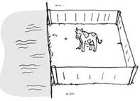
What is perimeter? _____________________________________
_____________________________________

How do you find perimeter?______________________________

Express perimeter of these shapes in terms of x.
- 3x + 2 2. x

x + 6
2x + 4

3. 4. 2.7x – 1.9
$\frac{2}{3}$x ½ x + 1 3.4x + 3.2

$\frac{5}{3}$ x - 10

What is area? ________________________________________
________________________________________

How do you find area of a rectangle? ______________________
Express the area of these rectangles in terms of x.
- 5x + 3 2. 6 + 4x
4 7

3. 2.8x – 4 4. 8 – $\frac{1}{5}$x
9 ¾

