Integer Addition Models HW Name:_____________________________________________

Part 1: Crayon/Marker Models
Choose one color to represent positive integers and one color to represent negative. Model each
addition problem, cancelling out opposite pairs, and find each sum.

- -4 + 6 2. -5 + -3 3. 1 + -3 + -2 + 4

4. -7 + 4 + -2 5. -3 + 6 + -2 6. -1 + 2 + -3 + 4 + -5

Part 2: Number Line Model
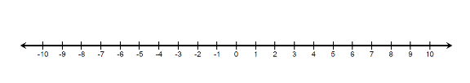
Use the number line to model each addition problem, then find the sum.

7. -4 + 8

8. -8 + 12

9. 3 + (-6)

10. -4 + (-3)

