Integer Addition Models
Part 1: Model using chips

- -3 + 4 2. -2 + 5 3. -1 + -5 4. -6 + 2

5. -7 + 3 6. -3 + 6 7. -4 + -3 8. -3 + 2 + -1 + 5

Part 2: Number Line Model
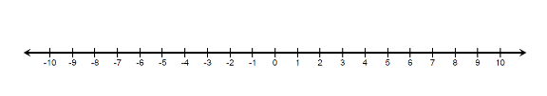
Use the number line to model each addition problem, then find the sum.

7. -8 + 7

8. -7 + (-2)

9. 5 + (-12)

10. -4 + 13

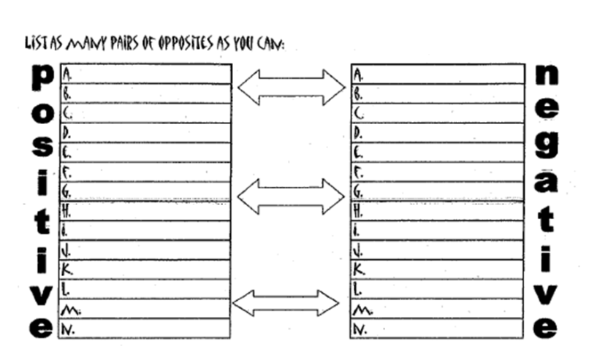
Opposites (Additive Inverse)

Think about it with your table…
1. If start at the bottom of a staircase and go up three steps and then down three steps, where do you end up?
2. From a start line, if you take four steps to the left, and the four steps to the right, where do you end up?
3. If you deposit $10 into an empty bank account, and then withdraw $10 from the account, how much money is left in the account?
4. If you start at zero and add 7, then subtract 7, where do you end up?
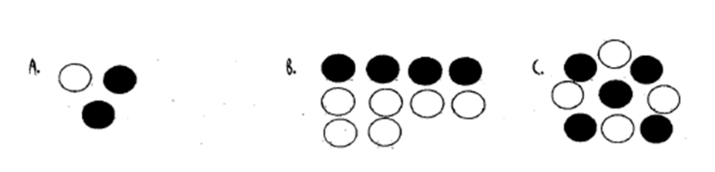
5. What do opposites do to one another?
6. Consider the models below. Let a black circle represent a +1 and a white circle represents a -1, what are we left with?

A number and its opposite are called ______________ _______________. Additive inverses sum to 0.

