Solve each problem below. Record your answers using the versatiles, and call me over when you have finished so that I can check your work!
1. The football team needs 10 yards for a first down. The team loses 9 yards and then gains 12 yards. How many yards does the team need for the first down now? | 2. Brianna has -$37 in her checking account. She deposits $150. Then she writes a check for $61. How many dollars does she have in her checking account now? | 3. Marie owes $32 to her mother. She borrows $10 more from her mother. Then she gets a paycheck for $50 and pays her mother back. How many dollars does Marie have now?
4. Jose has -75 points. He wins 200 points; then he loses 25 points. How many points does he have now? | 5. Yolanda writes checks for $59 and $43. She also deposits $50 in her checking account. What number represents the change in her account balance?  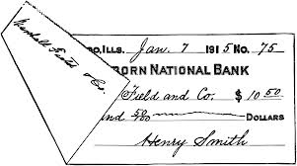 | 6. Robert has 8 points. He loses 45 points; then he wins 14 points. How many points does he have now?
7. There are 125 people on the train. At the next stop, 10 people get off the train and 35 people get on the train. How many people are on the train now? | 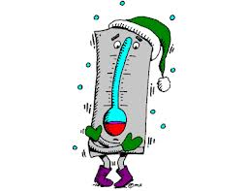  8. The temperature is -15°F. The temperature rises 7°F. How many degrees is it now? | 9. Death Valley, CA is 282 feet below sea level. Suppose a balloon takes off from Death Valley. The balloon rises 200 feet; then it drop 30 feet. What integer represents the number of feet above or below sea level the balloon is at now?
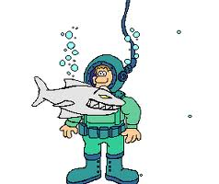  10. The diver is at -100 feet. He goes 25 feet deeper; then he comes up 60 feet. In feet, what is the diver’s location now? | 11. Abdul writes checks for $95 and $118. He also deposits $28 into his checking account. What number represents the change in his account balance? | 12. A balloon is 53 feet above the ground. It rises 65 feet; then it drops 67 feet. How many feet above the ground is the balloon now?

A.  7 | B.  100 | C.  -23 | D.  52 | E.  -112 | F.  8
G.  150 | H.  -65 | I.  -8 | J.  51 | K.  -52 | L.  -185

