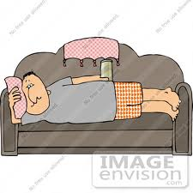
- A $500 couch is marked up 20%. What is the new price of the couch?

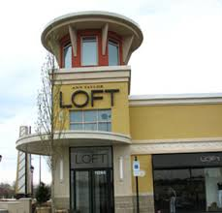
- I get a 15% discount at Ann Taylor Loft. If I find a shirt I like for $20, how much will I have to pay for it?

- A playstation game is $35, plus 10% tax. What is the total price of the game?
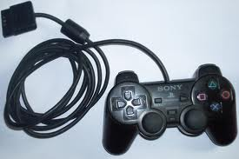

- Florists mark up roses 15% for Valentine’s Day. If a dozen roses is normally $20, how much do they cost on Valentine’s Day?

- A couch priced at $300 is on sale for 40% off. What is the sale price of the couch?

- My bill came to $40. I am going to leave a 20% tip because the waitress was just SO awesome. How much will I spend in total?
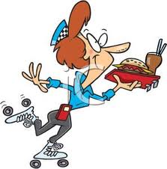
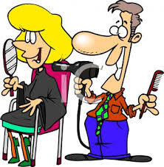
- My hair cut costs $40, but I also tip the girl 20%. What is the total cost for me to get my hair cut?

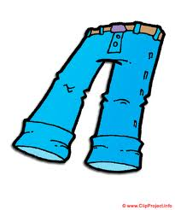
- A pair of jeans priced $20 are subject to 5% sales tax. How much are the jeans?

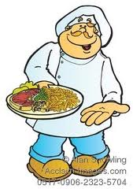
- The dinner bill came to $60, and you leave a 10% tip. What is the total bill?

- A pair of flip-flops costs $10, plus 5% sales tax. How much are the flip flops?
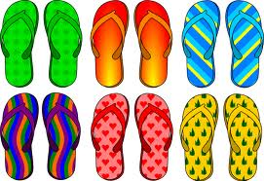

- I got a pedicure for $30, and I tipped the girl 10%. How much was my total bill?
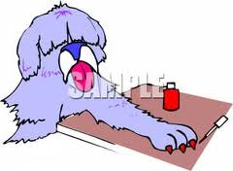

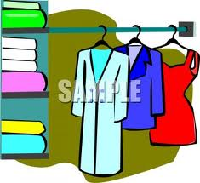
- A retailer marks their clothing up 20% over the wholesale price. How much would a $10 shirt retail for?

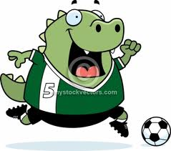
- On a super clearance special, soccer cleats were marked down 65% off. If the cleats are normally $40, what is the sale price?

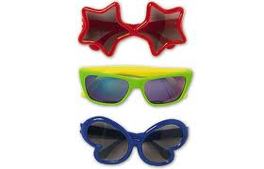
- Alisha wants to buy a pair of sunglasses priced $10. How much will the sunglasses cost after 5% sales tax?
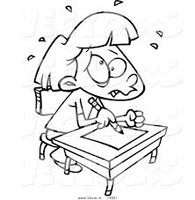
- On a test of 40 questions, Heather answered 80% of them correct. How
many questions did Heather get
correct?

- I planted 20 trees in my backyard, and 90% of them survived. How many trees survived?

