- A black ant travels $\frac{9}{8}$ inches in $\frac{1}{2}$ minute and $5\frac{5}{8}$ inches in 2 ½ minutes. What is the ant’s speed in inches per minute?

- A red ant travels $\frac{9}{8}$ inches in ¾ minutes and $3\frac{3}{8}$ inches in $2\frac{1}{4}$ minutes. What is the ant’s speed in inches per minute?
Proportional Reasoning Review

- What is the red ant’s speed in inches per hour?

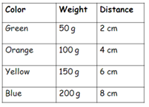
- What equation would represent the relationship between distance and weight shown in the table below?

- Determine the unit cost in price/ounce for each candy in the table below:
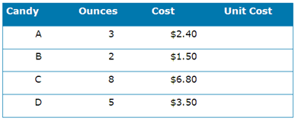

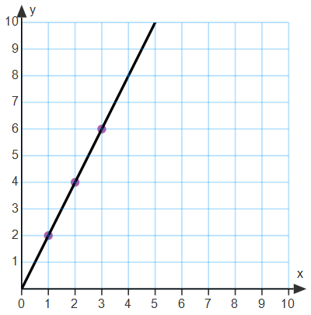
- Does the graph to the
right represent a
proportional relationship?
If so, what is the equation?

- Does the equation: $y=\frac{1}{2}x-7$ represent a proportional relationship? Why or why not?

- The copy machine makes copies at a constant rate as shown in the table below. How many copies will it make in 15 minutes?

Minutes | 1 | 2 | 3 | 15
Copies | 28 | 56 | 84

- Does the graph below show a proportional relationship? Why or why not?
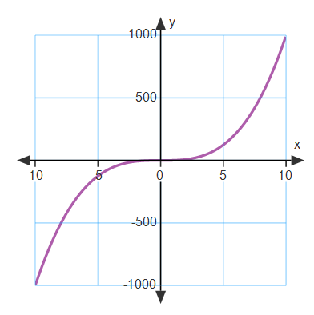

- Does the graph below represent a proportional relationship? If so, what is the constant of proportionality?
